Helpsheet – Using Wordpress

Logging in
- Visit http://lncn.eu/digiedblog

- Click Log in with username and password | 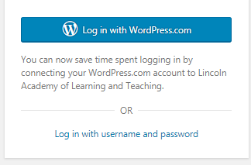
- Use your University username and password.
E.g. dwakefield
Remember: Click the box stating you are not a robot for security. You might be asked to click on several pictures to confirm your identity
- Click Login

You will now be taken to the Dashboard where you can get information about your webpage.

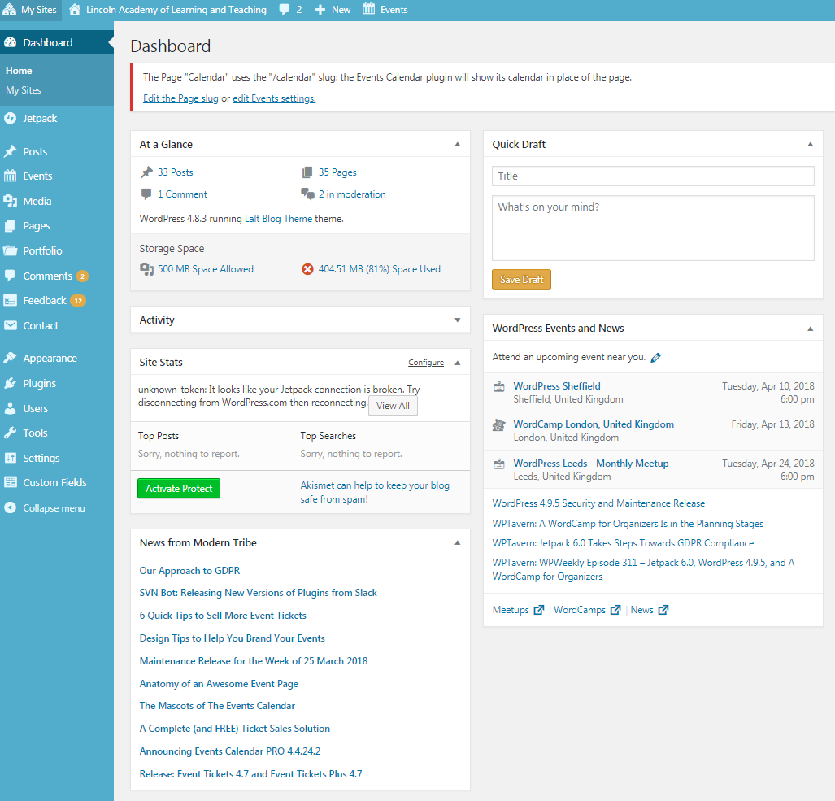

Posting a blog/adding media

- Click Posts on the left-hand side menu

- Click ‘Add New’ to create a new post

- Click Enter Title here to add a name for your blog post  Tip: Blog post titles should be short  - Type some text in the box below. The icons above the text are formatting tools. Very similar to that found in Microsoft Word | 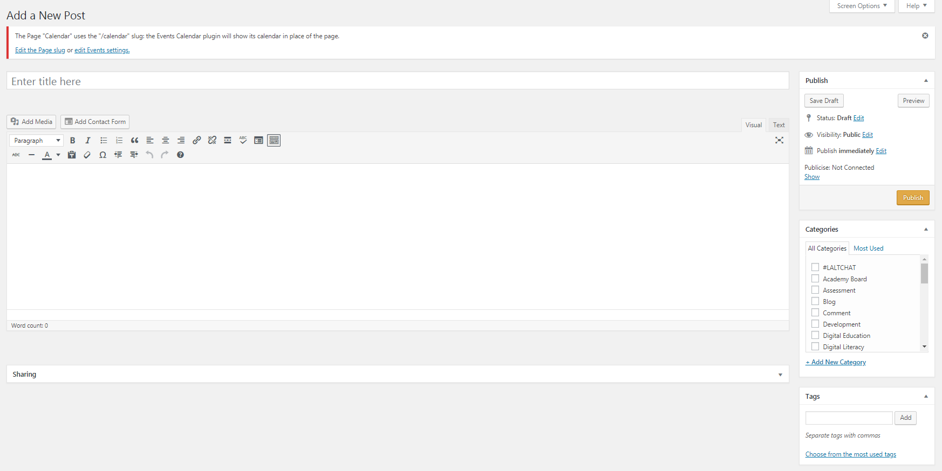
- If you would like to add media, such as a picture,
Click ‘Add Media’.
- To add a picture/file  Click ‘Upload files’ | 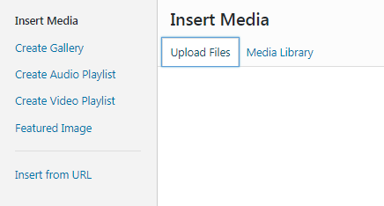
- Drop files anywhere in that window or select files to upload | 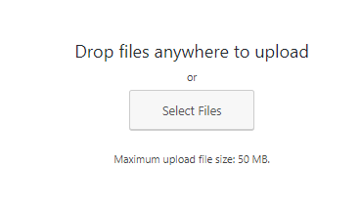
- Click Insert into Post to add your media. | 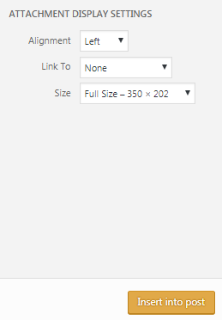
- Categories help you organise your posts. Plus they help other users find your posts. You can either use a pre-populated | - Tags help users search for key words. I.e. if you have tagged your article as ‘engagement’ users who search for this phrase will be pointed towards your post. | - Once you have completed your post you can click preview to see what your blog post looks like.  You can also click publish to make your blog live.

Commenting on someone’s blog post

- Click the home button in the top left hand corner. Then click visit site.
- Find a blog post you would like to comment on. Then click on the title/picture to load the blog post.
- Scroll to the bottom of the post and you will see a section which says leave a reply  (this has to be turned on in your setting to allow feedback) | This is a representational image. All blog sites are themed differently.
- Type your comment and click ‘post comment’.

