Helpsheet – How to use Microsoft forms

Accessing Microsoft Forms

- Visit 365.lincoln.ac.uk | 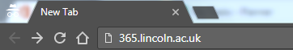
- Use your University Credentials to sign in. If you are already in the university network this should be done automatically.

- Click on Microsoft forms | 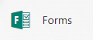

Creating a New Form/Quiz

- Click create new form/quiz  (The process for both will be the same) | 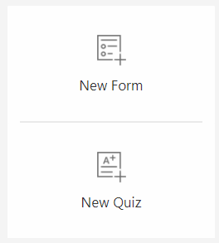
- Give a title to your form by clicking in the title box. | 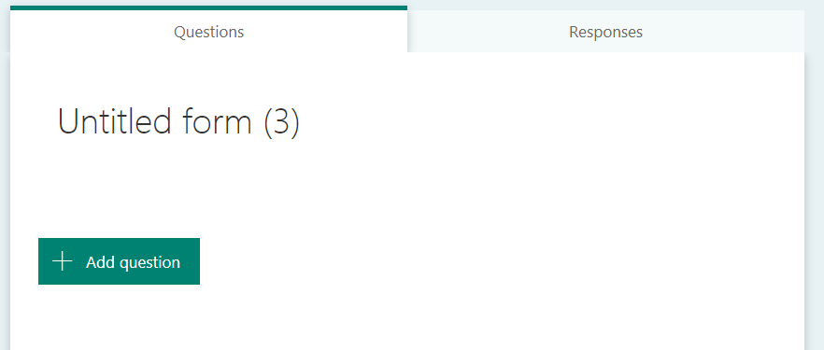
- Click description to add information about the form.

- Click add question and choose type:  - Choice (choose one or multiple options)  - Text field (users input their own answer)  - Rating (How well liked it is)  - Date (Choose a date)  - Ranking (Allow students to create an order for their favourite options)  - Likert (Give statements with several options for each statement) | 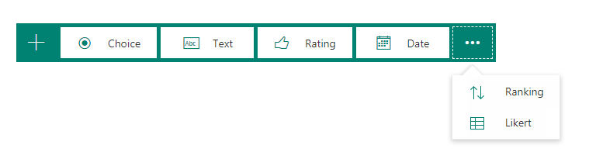
- Add as many questions as you would like.

- You can always see how your form looks by using the preview button. | 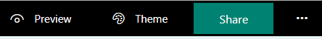

Sharing a Form/Quiz

- Once you’re happy with the form you can share it to a wider network to gather data.
- There are now several options to support you with sharing your form. | 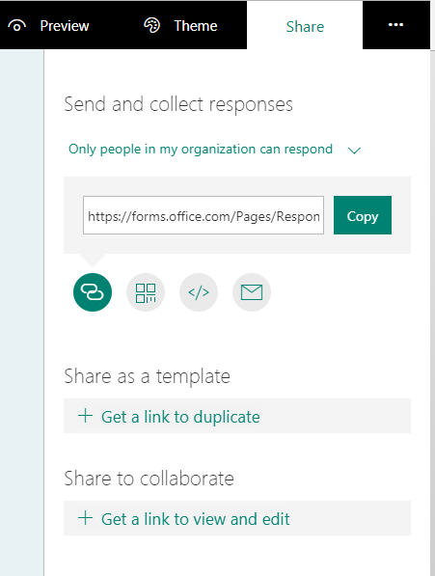 | 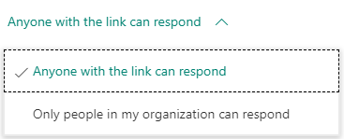  You can choose who will receive your form.
 |  | Click copy to share this link with students/academics for them to complete the form.
 |  | You can also send the form as a QR code, HTML Embedded form or via an email
 |  | You can share this form as a template to be used by another person.
If you would like to collaborate creating a form with other people
You can click this link here. This will send them an copy you can both edit together.

Viewing responses

- Go to the forms homepage. Find the survey you sent out. You can see how many responses you have received. Click on the form. | 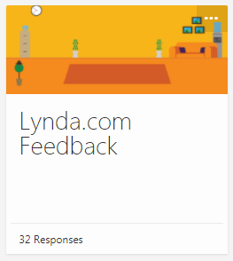
- At the top of the page click responses.

- You will now be shown answers to all of your questions | 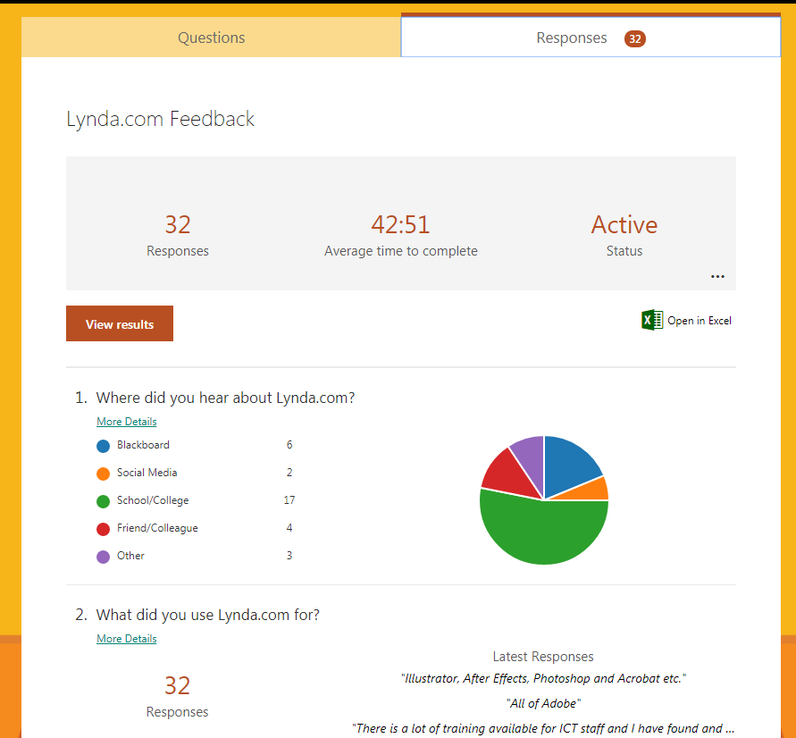
- You can export the data to excel by clicking

